**PENGELOLAAN KEUANGAN DAN INVENTARIS BARANG**

“CV. Nitah Tirta Makassar”

# **Intro & Goal**

Our goal is to build an internal use website for **CV. Nitah Tirta**, aimed at transforming manual record-keeping into a computerized system. The system will cover various financial and inventory operations, including employee payroll, sales, expenses, incoming and outgoing goods, and the generation of balance sheets.

# **Who’s** it for?

This website is intended for internal users of **CV. Nitah Tirta**, specifically the owner, admin, and karyawan. It aims to simplify various transaction recording processes and the management of inventory items.

# **Why** build it?

1. To simplify the process of recording business operational needs within a single integrated information system.
2. To improve time efficiency by completing tasks faster and more accurately.
3. To replace Excel spreadsheets, which have limitations in scale and data capacity, and can only be accessed or managed from a single device.

# **What** is it?

## Glossary

1. **Post** - new product hunt submissions
2. **Comments** - comments on a post
3. **Replies** - replies to comments
4. **Vote** - votes for a post
5. **Index View** - homepage of Product Hunt (all users can view this)
6. **Detailed View** - permalink page for each post
7. **Profile View** - user profile page

## User Types

|  |  |  |
| --- | --- | --- |
| user Type | Description | Access Rights |
| Admin | Responsible for managing transaction and inventory data, as well as addning new users (Karyawan) | Full Access (Excluding Neraca Saldo) |
| Owner | Can view and download all records in the system, create Neraca Saldo reports, and download Karyawan payrolls | Read, download, and input Neraca Saldo Reports |
| Karyawan | Read & Download Karyawan Payroll | Read & Download Karyawan payroll |

## Index View

1. When the user successfully logs in, display a bar with the message “Welcome” followed by the user’s name.
2. The main dashboard contains three master data modules: Items, Vendors, and Hotels.
3. Employees can only log in using the username and password provided by the admin.

## Detailed View

1. The detail pages in the forms **“Upah Karyawan”**, **“Laporan Penjualan”**, and **“Persediaan Barang”** contain various information such as date, item code, and item name, which are sourced from the master data.
2. The **“Ambil Upah”** button on the Upah Karyawan page can be clicked when the employee is allowed to download their salary, after which it will be reset automatically.

# **User Onboarding Plan**

To ensure that all users can easily understand and operate the Financial and Inventory Management Information System, the onboarding process is carried out in a structured and gradual manner as follows:

1. Initial Target Users

* Admin: Has access rights to manage and perform CRUD operations on master data and menu lists containing information such as data supplier, barang, upah karyawan, laporan penjualan, and laporan pengeluaran.
* Owner: Has access rights to view master data and menu lists, download reports, and create the final Neraca Saldo report.
* Karyawan: Can access the system using the username and password provided by the admin.

1. On-Boarding Method

The onboarding process will be conducted through a live system demo within the CV. Nitah Tirta environment.

1. First User Actions

Once the system is active, users will follow these initial steps:

* **Login** for the first time using the account created by the admin for Karyawan
* **Admin:**

1. Input master data (Barang, Vendor, and Hotel).
2. Manage user data for Karyawan
3. Trying to make reports

* **Owner:**

1. Review all data input by the admin.
2. Access the main system dashboard.
3. Try creating a Neraca Saldo.

* Karyawan

Access the Upah Karyawan menu and try downloading a sample payslip.

1. Feedback and Evaluation

After the onboarding phase, users will be asked to complete an evaluation form to test system feasibility using the User Acceptance Testing (UAT) method (journal link: <https://doi.org/10.62951/switch.v3i1.330>).

If any errors or bugs are found during the first few days of use, developers will perform fixes within a defined timeframe.

1. Objective

The purpose of onboarding is to ensure that all users understand the system’s functions and navigation, as well as to collect user feedback as a basis for system improvement.

# **Usecase**

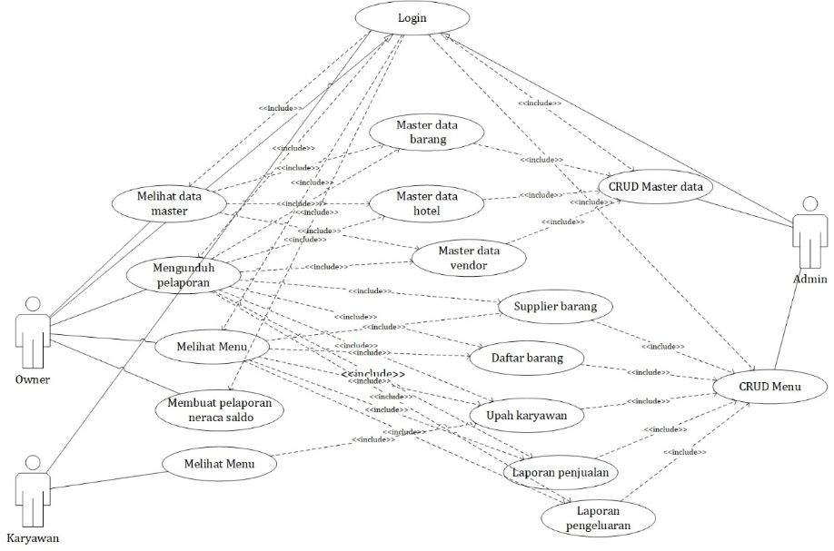

# **User Flow**

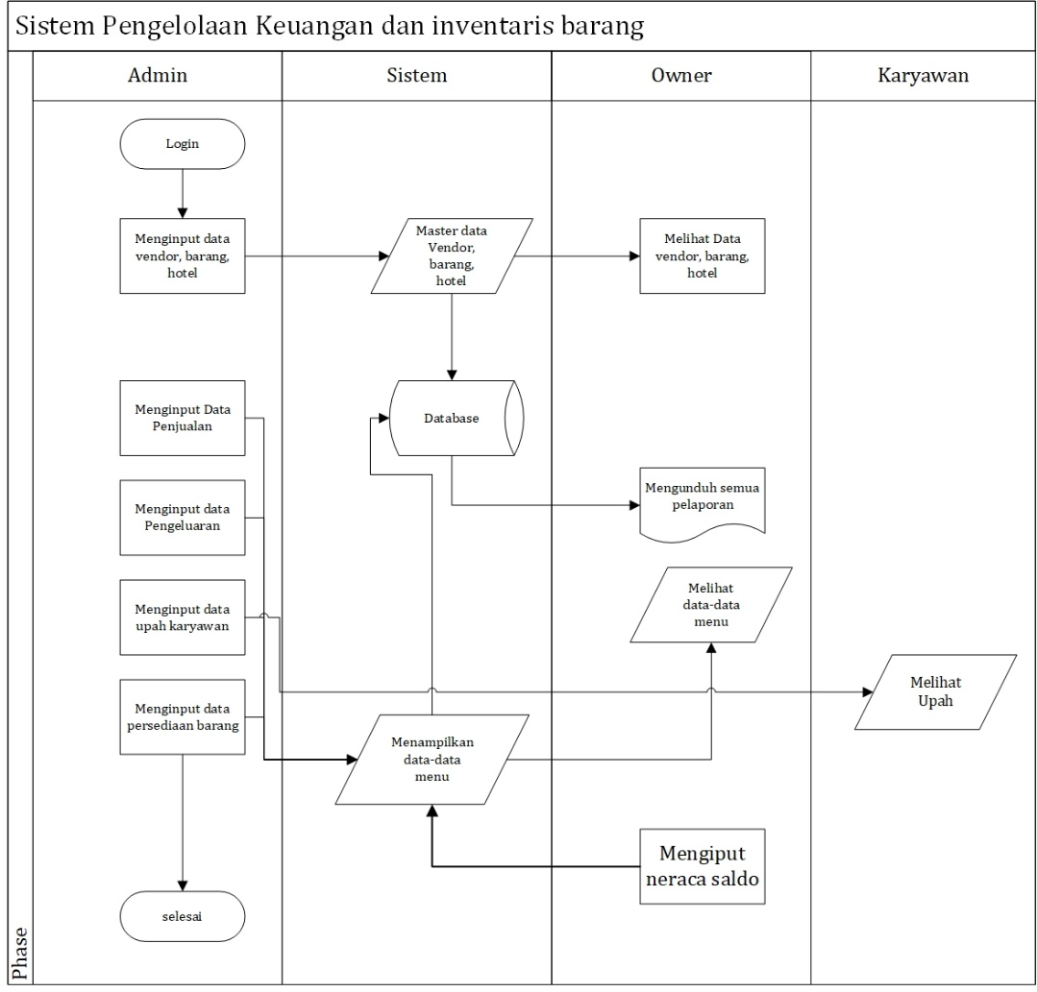

**Mockups**

*Link Figma :*

<https://www.figma.com/design/lmTJbku4fXxwoMlVEqWr9M/Untitled?node-id=0-1&t=MX7enSE4ushZa2LO-1>

**Index View**

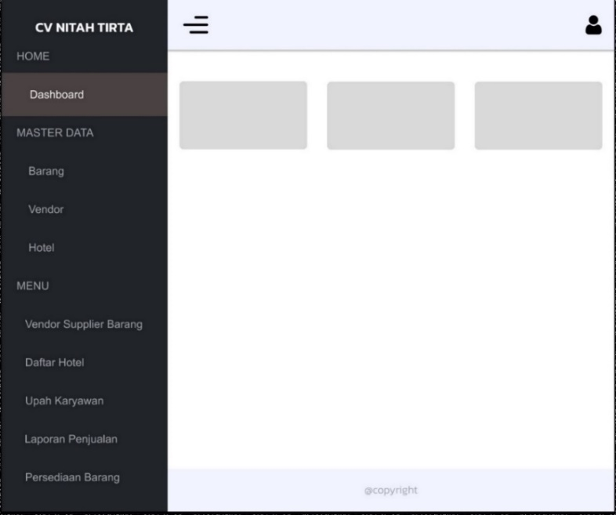

**Detail View**

**Upah Karyawan**

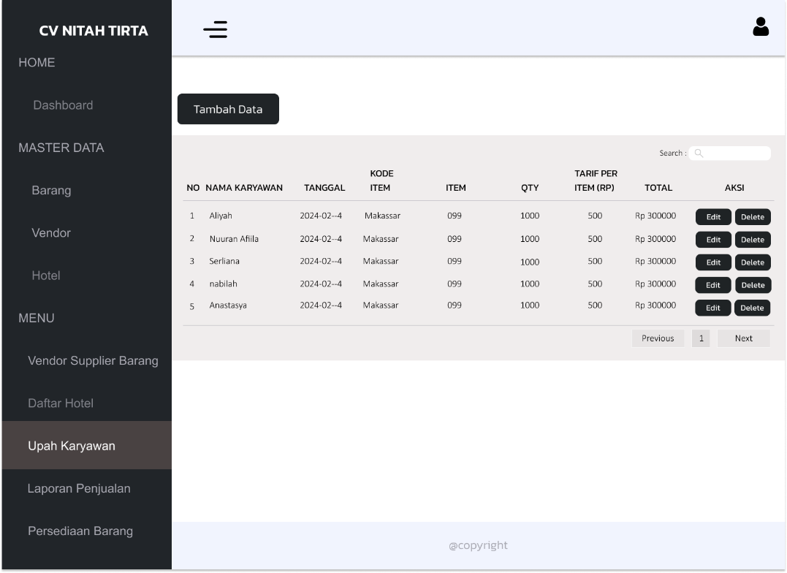

**Laporan Penjualan**

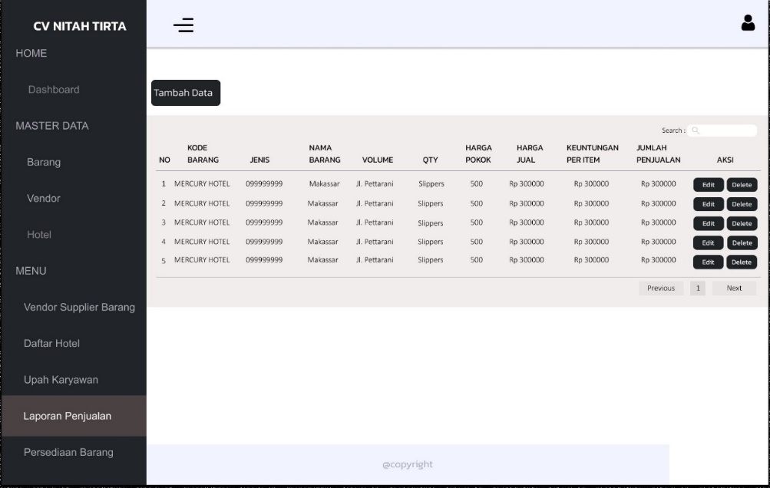

**Persediaan Barang**

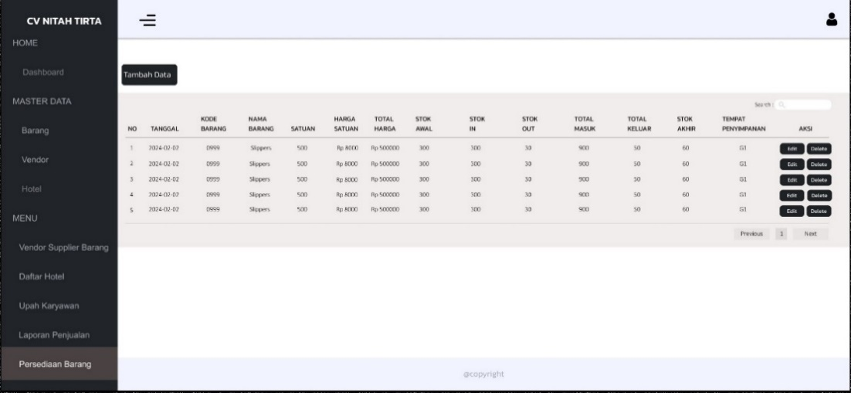

**Upah Karyawan**

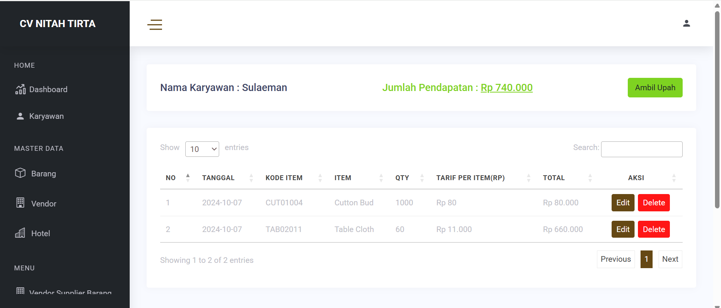

# **Tech Notes**

**Models**

Daftar_hotels = (hotel_id, barang_id, qty, harga_jual)

Laporan_penjualan = (barang_id, volume, qty, harga_pokok, harga_jual)

Master_barang = (kode_barang, jenis, nama_barang, harga_satuan)

Master_hotel = (nama_hotel, kontak, kota, alamat)

Master_vendor = (nama_vendor, alamat, email, phone)

Neraca = (no_kode, nama_akun, debit, kredit, tanggal)

Pengeluaran = (tanggal, uraian, kategor, nilai)

Persediaan_barang = (barang_id, tanggal, satuan, stok_awal, stok_in, stok_out, tempat_penyimpanan)

Supplier_barang = (vendor_id, barang_id, satuan, harga_pokok)

Upah_karyawan = (nama_karyawan, barang_id, tanggal, qty, tarif)

Users = (roles, username, password)

## Post-Launch Marketing

1. **Product Deconstructions Blog Posts**

**------------------------------------------------------------------------------------------------------**

**OLD STUFF BELOW**

**------------------------------------------------------------------------------------------------------**

**Architecture**

1. Homepage Landing page (not signed in)
2. Homepage Log In
3. Dashboard

**Homepage - Not Logged In**

The interface design of this landing page clearly displays the company name at the top, followed by a concise and informative company profile section, arranged in a simple and easily accessible layout for users.

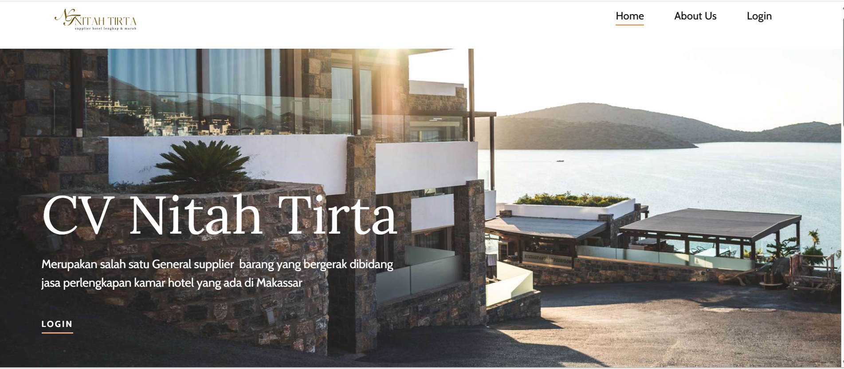

**Homepage Feed Logged In**

The login interface design is simple, featuring input fields for username and password, along with a minimalist and easily accessible "Sign me in" button.

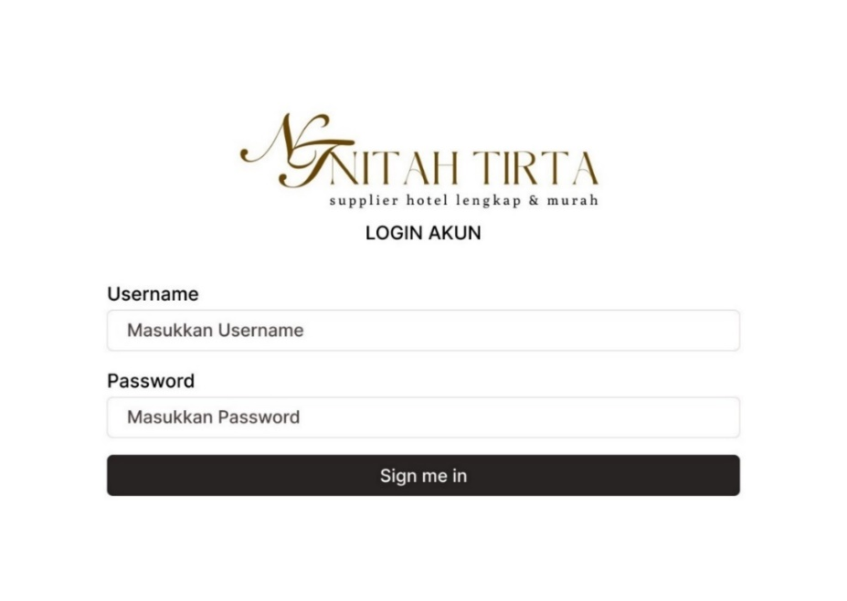

**Dashboard**

The login interface design is simple, featuring input fields for username and password, along with a minimalist and easily accessible "Sign me in" button.

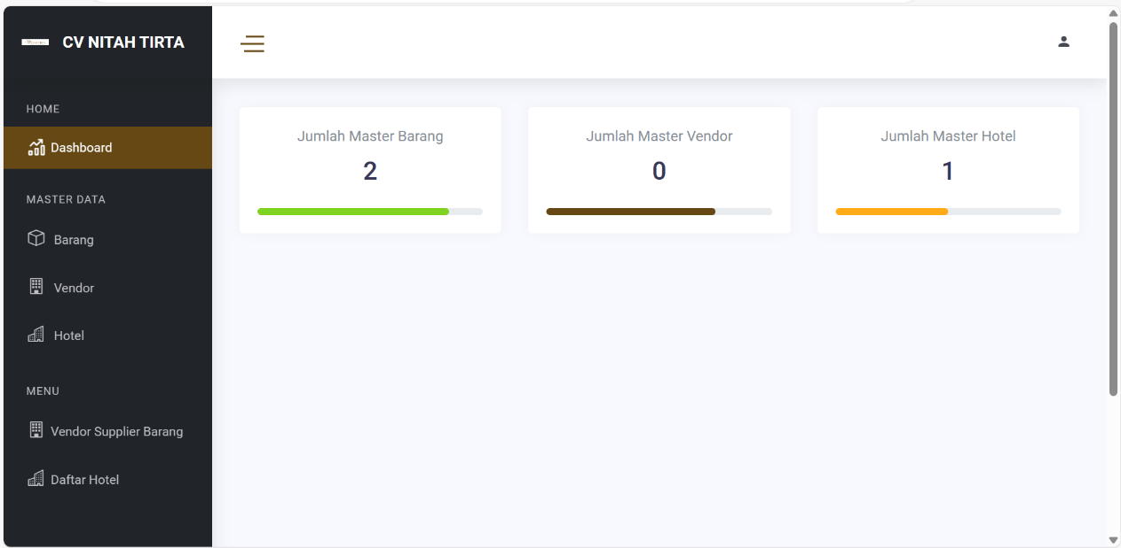

# **Future Plan Ideas**

* **Mobile Accessibility** – Enable access through mobile devices (smartphones and tablets) to make it easier for users such as owners or admins to monitor financial and inventory data anytime and anywhere.
* **Real-Time Data Synchronization** – Implement real-time data updates across all modules (transactions, reports, and inventory) so that users always receive the most accurate and up-to-date information without needing to refresh manually.
* **Enhanced User Interface (UI)** – Improve the visual design of the dashboard and reporting pages with a cleaner layout, better color contrast, and modern typography to enhance user experience and readability.
* **Data Visualization Dashboard** – Add interactive charts and graphs for financial reports and inventory summaries to simplify analysis and decision-making.
* **Notification System** – Introduce alert notifications for important events such as low stock levels, upcoming payment deadlines, or new report submissions.